1.Introduction

Background

Issues

How to solve the issue

Which will be the technology like in future?

The problem overview

In recent decades, issues emerge with the development of transportation: about traffic congestion, especially in urban centres; about the impacts on energy consumption and air pollution; and about highway-related fatalities and injuries due to crashes. [J., Powell, G., R., Yoon, R., Fikentscher, J., Doyle, C., Sade, D., Lukuc, M., Simons, J., & Wang, J. (2014, August). *Vehicle-to-vehicle communications: Readiness of V2V technology for application.* (Report No. DOT HS 812 014). Washington, DC: National Highway Traf c Safety Administration] governments and organizations all over the world have recognized the need to address these issues. According to the World Health Organization (WHO) fact sheet about road traffic injuries, on a global scale, around 1.25million people die from traffic crashes every year. [“Scenarios, requirements and KPIs for 5G mobile and wireless system,” ICT-317669-METIS/D1.1, METIS deliverable D1.1, Apr. 2013. [On- line]. Between 20 and 50 million more people suffer non-fatal injuries, with many incurring a disability as a result of their injury.

Between 20 and 50 million people suffer from a disability as a result of traffic crashes. Without sustained action, road traffic crashes are predicted to become the seventh leading cause of death by 2030. Human error is the main reason leading to traffic crashes. World Health Organization. (2016, November) Road track injuries-fact sheet. (last accessed 03-March-2017). [Online]. Available: http://www.who.int/mediacentre/ factsheets/fs358/en/. So it is urgent to create wireless communication to enable the vehicles to exchange their datum with each other and roadside infrastructures. This new creating wireless communication technology is designed to provide a solution to ensure high reliability under challenging vehicular environment, such as high relative speed between transmitters and receivers. Also, low latency is required for safety-related applications. Such as vehicle trash ahead of the highway. Messages should be broadcast to all vehicles close to the location in a short time. 【relay Selection for Heterogeneous Transmission Powers in Connected Vehicles】

History of ITS

Over the past decade, the development of Cooperative Intelligent Transport Systems(C-ITS) has the potential to play a significant role in addressing the increasing problems of congestion, safety and environment in Europa. [study on the deployment of C-ITS in Europa: final report] The C-ITS Platform has been launched in 2014 and has delivered the final report of its first phase in January 2016.Preparatory work for the Delegated Act has started in May 2016 with a first meeting of Member State experts. And the preparatory work builds on the findings of the first phase of the Platform for the Deployment of C- ITS in the EU. The Amsterdam Group complements the work of the C-ITS Platform through connecting the C-ITS pilots and deployment initiatives with the goal of interoperable deployments which is facilitated by sharing information as well as discussing and mitigating possible divergent approaches. The Amsterdam Group was formed in 2011 as a strategic partnership between the automotive industry within the CAR 2 CAR Communication Consortium (C2C-CC) and infrastructure organisations (CEDR, ASECAP, POLIS) as committed core stakeholders in the C-ITS deployment. [State-of-the-Art Analysis of C-ITS Deployment]

The best solution

Recently, governments and companies are supporting the development about C-ITS and vehicle-to-vehicle (V2V) communication.V2V communication involved with automatically connected vehicles and road infrastructures has arisen great attention. [Multi-hop delay reduction for safety-related message broadcasting in vehicle-to-vehicle communications ], which serves as one of the key technologies for realising a plenty of applications related to vehicles, drivers, passengers and pedestrians. Some obvious benefits of V2V communications, including improving road safety by warning drivers under some dangerous condition, reducing time delays when vehicles pass the tollbooths, reducing energy consumption, enhancing mobility, increasing service reliability, enabling groups of cars to exchange multimedia information, and supporting economic development [Channel Modelling for Vehicle-to-Vehicle Communications]& [study on the deployment of C-ITS in Europa: final report] And V2V communication is a remarkable embodiment to support road safety and traffic efficiency applications in future C-ITS. Investigations on all aspects of ITS are rapidly increasing. [2] ITS project, <http://www.its.dot.gov/index.htm,Nov.2007>. Also, governments,

industries and academia have invested plenty of capital for V2V and C-ITS. [V2V Channel Characteristics and Models for 5 GHz Parking Garage Channels]

United States of America (USA) is one of the leading countries in this field. On July 6, 2012, President Obama signed into law a two-year transportation reauthorization bill, the Moving Ahead for Progress in the 21st Century Act. Part of this law is dedicated to ITS activities. The possibility to reduce crashes in USA brought about the focus on a set of critical crash V2V safety applications. [112th Congress-Public Law 112-141, “Moving ahead for progress in the 21st century act (MAP21),” U.S. Government Printing O ce, pp. 1–584, January 2012.

Also in china, State Council announced plan to build Intelligent Connected Vehicles Pilot Area in Shanghai on September 2015. [C-ITS Status in China — To the 8th ETSI ITS Workshop Sophia Antipolis, March 08,2015] [http://www.gov.cn/zhengce/2015-09/30/content_2940909.htm]

Main limitation challenge

In contrast to the traditional cellular mobile radio link, the V2V propagation channel is much more dynamic, since it consists of two non-stationary transceivers, closely located to the ground level. Current legacy solutions for V2V communications are based on 802.11p standard with infrastructure assistance in long term evolution (LTE) network.

[C. Lottermann, M. Botsov, P. Fertl, and R. Mullner, “Performance evaluation of automotive off-board applications in LTE deployments,” in *IEEE Vehicular Networking Conference (VNC)*, 2012. ]

However, 802.11p legacy solution is mainly optimized for a WLAN-type of environment with much lower mobility.

V2V communications are often divided into varied environments, such as highway, urban, and rural areas. Vehicles under these scenarios always need higher velocity. [V2V Channel Characteristics and Models for 5 GHz Parking Garage Channels], especially under highway scenario. In this research, highway is the main scenario which used for analysing the performance of V2V.

On the other hand, the operating performance for vehicular communication is not enough, especially in the field of latency and reliability. So the new generation of wireless communication should be able to meet the high requirements of reliability and availability. In order to meet the demand of new developing service types like vehicular communications, fifth generation(5G) is designed to fulfil these requirements. [direct vehicle to vehicle communication with infrastructure assistance in 5g] Some publications have already discussed about the feasibility to provide V2V communication in 5G network. [3] L. Le, A. Festag, A. Mder, R. Baldessari, M. Sakata, T. Tsukahara, M. Kato. *Infrastructure-assisted communication for car-to-x communication*, Proceedings of 18th ITS World Congress and Exhibition 2011.

[4] Vinel, A. *3GPP LTE Versus IEEE 802.11p/WAVE: Which Technology is Able to Support Cooperative Vehicular Safety Applications* Wireless Communications Letters, IEEE, vol.1, no.2, pp.125,128, April 2012.

[5] Araniti, G.; Campolo, C.; Condoluci, M.; Iera, A.; Molinaro, A. *LTE for vehicular networking: a survey* Communications Magazine, IEEE, vol.51, no.5, pp.148,157, May 2013

what do I hope to achieve motivation?

single-hop vs twice-hop

over the past few years, single-hop vehicular transmission or multi-hop vehicular transmission in V2V communication has be widely used to deliver messages, such as hazardous situation information, road congestion information and traffic warning messages in V2V communication. These are all safety-related applications in order to reduce the possibility of vehicle trashes. So the transmission range and time delay concerned messages transmitting between transmitter and receivers count.

//Why we don’t consider about the one-hop

For single-hop broadcasting, because of the limitation of transmission range and the limitation of time and frequency resources. The single-hop communication is not adequate in V2V communication due to low efficiency and large latency.

Why we don’t consider about the multi-hop

Also, the use of multi-hop is spectrally inefficient as, in most cases, they need to transmit on orthogonal channels. And the performance of relaying processes along multiple-hop is unsuitable. [A. Bletsas, A. Khisti, D. P. Reed and A. Lippman, “A simple cooperative diversity method based on netwrok path selection”, *IEEE J. Sel. Areas*

*Commun.*, Vol. 24, No. 3, pp.659-672, Mar. 2006.] In a multi-hop network, the same problem can be defined as hop selection and a related scheme is proposed in L. Ruan and V. K. N. Lau, “Decentralized dynamic hop selection and power control in cognitive multi-hop relay systems”, *IEEE Trans. on Wireless. Comm.* , Vol. 9, No. 10, pp. 3024-3030, Oct. 2010. ] which involves power control as well to co-exist with the primary users. A common denominator in all these papers is that the secondary nodes are assumed to adapt their transmission power in order to always satisfy the interference constraint in underlay settings. However, this may not be the case in every network and the secondary nodes may have fixed transmission power. [Reactive Relay Selection in Underlay Cognitive Networks with Fixed Gain Relays]

hop transmission and multiple-hop transmission with high efficiency, and twice-

Why we consider about the twice-hop my contribution //

Objective what I want to get?

In this research, twice-hop transmission is utilized which is the trade-off between single- hop transmission just need to select one relay. The efficiency of twice-hop transmission is decided by adapting each transmission with an appropriate modulation and coding scheme (MCS) and selecting the proper relay vehicles. Due to different links experience varied channel states. It is important to adapt a MCS with a more robust link performance in case of experiencing worse channel states. A more robust transmission means a much lower coding and modulation rate. However, this also means that more frequency and time resources are needed for the same size of packages.

Also, Unreasonable selection of the relay vehicles to retransmit important information could seriously degrade the ITS applications performance in terms of latency, overhead, and reception rate. The terrible performance of the decision might have devastating consequences on the performance of the ITS applications and consequently on the safety of drivers and pedestrians. [Relay Selection for Heterogeneous Transmission Powers in Connected Vehicles]

Relay selection

Relay selection is one of the main buildings blocks of cooperative relaying and commonly channel conditions of relay links are main selection criteria. The impact of choosing a given relay node on communication of surrounding nodes and overall network has to be taken into account. The relay selection is mainly done once at network start up periodically at transmitting section. Many papers have been published based on different relay selection approaches. [Survey on Cooperative Relay Selection Approaches Nimmi Krishna M.R, Shiras S. N Department of Electronics and

Communication, MBCET, Trivandrum, India] However, many relay selection schemes demand the continuous monitoring of all available channel links, Regarding the relay selection mechanism, threshold-based relay selection has been proposed as an efficient technique for improving performance. [ S. S. Ikki and M. H. Ahmed, “Performance of multiple-relay cooperative (A-1) diversity systems with best relay selection over Rayleigh fading channels,” *EURASIP J. on Advances in Signal Processing*, p. 145, 2008. ]

The threshold-based relay selection relies on SINR and BLER thresholds to decide from a set of N available ones which node is satisfied for cooperation between the source and the destination. Coding and modulation scheme(MCS) is adapted to reach a target BLER value below 10%.

The objective for designing the transmission system is to deliver the safety-related road information in a high speed with quite low latency. On the other hand, it is efficient to utilize the limited frequency and time resources.

Thesis organisation

The rest of the thesis is organized as follows.

**Review of the Literature**

**Methods**

**Results**

**Discussion**

**Conclusions**

Chapter2 **System model**

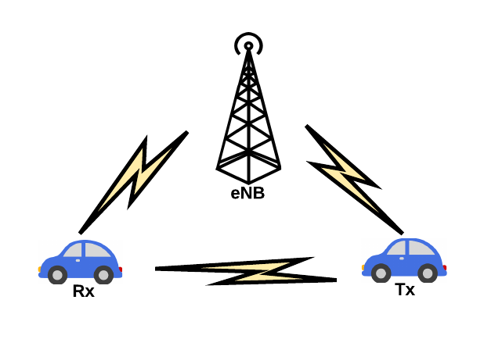In order to improve traffic efficiency and safety and to assist drivers to reduce the traffic accident and energy consumption, therefore, it is an efficient method that selecting relay transmits information to more vehicles in the transmission of one transmitter in V2V transmission. In this way, vehicles in the transmission range of the transmitter should listen to the multiple transmitted package concurrently. This communication process is a kind of twice hopping network where multiple receivers try to receive the same packet from one transmitter through selecting relay vehicle. In this part, we describe the models utilized in this work.

figure.1 direct V2V transmission with eNodeB

2.1 environment model

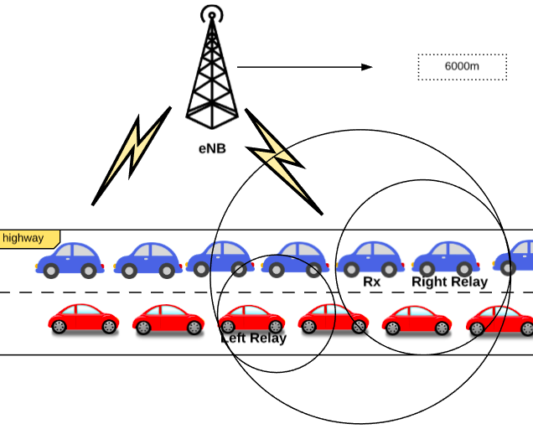

Figure.2 V2V transmission model

C-ITS can address the increasing problems of congestion, safety and environment. So it requires V2V communication working efficiently in any environment, such as urban, rural or highway scenario. In this research, under highway scenario is considered to detect the system performance of V2V communication.

As shown in Figure.1, V2V transmission model under highway scenario is implemented. And the highway has 3 lanes. In this model, a 20-kilometer highway is used for simulation. According the requirement, we assume the width of this highway is 20 meter. It is assumed that the coverage of each base station is 6000m.

|  |  |  |
| --- | --- | --- |
| Scenario: highway | | |
| Key parameter | value | unit |
| Length of highway | L=20 | km |
| Width of highway | W=20 | m |
| Lane of highway | La=3 |  |
| Range of base station | db=6 | km |
| Height of the antenna of base station | Hbs=1.5 | m |
| Height of the antenna of mobile station | Hus=1.5 | m |
| Transmission range of vehicle | Range=100 | m |

Table.1: Main parameters

2.2 deployment model

As Table.1 shows, the distance between two vehicles is 10 meter. So the deployment of vehicles on the highway is 100 vehicles per lane per kilometers.

$$UE=100×lane×db$$

So the number of vehicles under one base station is 1800. In addition, we assume the transmission range of each vehicle is 1000m.

And an isotropic and 1.5-meter antenna is installed on each vehicle. Also each base station is installed the same antenna.

2.3 Radio propagation model

The hata model is a radio propagation model for predicting the path loss of mobile transmissions in exterior environments. The model is suited for both point-to-point and broadcast communications.

$$C_{H}=0.8+\left(1.1\log_{10}f-0.7\right)h_{M}-1.56\log_{10}f$$

where

$C_{H}$ =Antenna height correction factor.

$f$ =carrier frequency.

Unit: Megahertz(MHz)

$h_{M}$ =height of mobile station antenna.

Unit: meter(m)

$$PL=69.55+26.16\log_{10}f-13.82\log_{10}h_{B}-C_{H}+[44.9-6.55\log_{10}h_{B}]\log_{10}d$$

$PL$: path loss in areas.

Unit: decibel(dB)

$h_{B}$: height of base station antenna.

Unit: meter(m)

$d$: distance between the base station and mobile stations.

Unit: kilometer(km)

|  |  |  |
| --- | --- | --- |
| Channel model: Hata model | | |
| Key parameter | value | unit |
| Transmitter power | 24 | dBm |
| Transmitter antenna gain | 0 | dBi |
| Receiver antenna gain | 3 | dBi |
| Carrier frequency | 2 | GHz |
| Operational bandwidth | 10 | MHz |
| Package size | 212 | Byte |
| Noise figure of mobile station | 7 | dB |
| Thermal noise level | -174 | dBm/Hz |

Table.2: channel model

As Table.2 shows, each vehicle transmits packages with a constant transmitting power of 24 dBm in each 10 MHz bandwidth. In this work, V2V communication utilize a carrier frequency of 2 GHz as frequency of transmission.

2.4 Traffic model

Traffic model specific for safety-related issue in V2V communication includes both periodic and event-driven package transmission. For event-driven package transmission, once a vehicle experiences certain events from local environment. The event-driven messages will be delivered to all the vehicles in the proximity. Due to the lower frequency of generating messages compared the frequency of periodic transmission for V2V communication, in this work, we utilize a periodic package transmission of 212 Bytes with 10 HZ periodicity for each vehicle.

2.5 Modulation and coding scheme

An appropriate modulation and coding scheme (MCS) is very important for transmission every time. Because of near-far effect, the links between transmitter and receivers in its proximity can experience varied channel states.

At the same time, it is a hard work to collect the real time channel state information(CSI) for at the transmitter side under highway scenario. So it’s vital to adapt to an appropriate MCS with a more robust link performance in case of links experiencing worse channel states.

A more robust transmission means that a lower MCS is required. However, a lower MCS means that more frequency and time resources are required to transmit the same size package. Therefore, the MCS is controlled by central service for each transmission based on real time system load.

In this work,

$$datavolume=packetsize×UE×8×period÷{10}^{6}$$

$$efficiency=datavolume÷bw$$

$datavolume$: the data volume.

Unit: Mbps

$efficience$: transmission spectral efficiency.

Unit: bits/Hz

$packetsize:$ the packet size.

Unit: Byte

UE: the number of mobile station.

$period$: the frequency of periodic transmission.

Unit: Hz

$bw$: the transmission bandwidth.

Unit: MHz

According to the calculation, we can decide the MCS efficiency according to the number of mobile stations, bandwidth and required size of packets. Decided efficiency to make sure these parameters such as how many users can be possible in these transmission resources. to make sure resource that is enough. The same size of users, if the BW is much smaller, then we need to use much larger MCS efficiency to transmit the same packet. if smaller user, then we can allocate much larger resource for them, then can transmit more packets.

Appropriate MCS means under certain bandwidth how many users that can serve. Because of the limitation of MSC, the number of user is also limited. More vehicles mean much larger MCS for the same bandwidth which need to serve more users.

When we get the efficiency value, we should select the appropriate value according to the table.3. the value selected should be equal to or just greater than the calculated efficiency.

|  |  |  |
| --- | --- | --- |
| CQI | Modulation | Spectral Efficiency |
| 0 | Out of range | |
| 1 | QPSK | 0.1523 |
| 2 | 0.2344 |
| 3 | 0.3770 |
| 4 | 0.6016 |
| 5 | 0.8770 |
| 6 | 1.1758 |
| 7 | 16 QAM | 1.4766 |
| 8 | 1.9141 |
| 9 | 2.4063 |
| 10 | 64 QAM | 2.7305 |
| 11 | 3.3223 |
| 12 | 3.9023 |
| 13 | 4.5234 |
| 14 | 5.1152 |
| 15 | 5.5547 |

Table.3 Modulation and Coding scheme

2.6 Noise model

Thermal noise (Nyquist noise) is the electronic noise generated by the thermal agitation of the change carriers inside of electrical conductor at equilibrium spectrum, which happens regardless of any applied voltage.

$$P_{dBm}=-174+10\log_{10}bw+NF$$

$P_{dBm}$: Power of noise

Unit: dBm

$bw$: the transmission bandwidth

Unit: Hz

$NF$: the noise figure of mobile station

Unit: dB

Chapter3 Relay selection for V2V selection

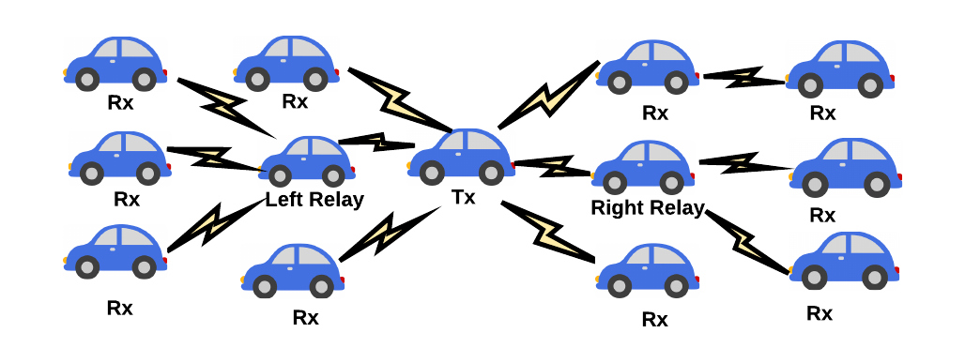

figure.3 V2V transmission through relay

Ch4 analysis the results

Ch5 conclusion

Ch6 summary

Algorithm 1: two sides relays decision

1. Deciding the appropriate MCS (modulation and coding scheme) and threshold BLER.

2. Mapping the distance between each receiver and transmitter to the BLER of each receiver.

3. Depending on the mapping table of distance and BLER calculated before, the distances of receivers which BLER values satisfied the threshold value are selected.

4. The distance of the receiver satisfied the maximal distance is the relay.

|  |  |  |  |  |
| --- | --- | --- | --- | --- |
| Transmission range=1000m | | | | |
| UE: number of users | First-hop Bandwidth:  MHZ | Second-hop  right-side  Bandwidth:  MHZ | Second-hop  left-side  Bandwidth:  MHZ | Successful transmission ratio |
| 1800 | 10 | x | x | 56% |
| 1800 | 10 | 10 multiplex | | 99.98% |
| 1800 | 10 | 5 | 5 | 95.90% |
| 1800 | 5 | x | x | 39.67% |
| 1800 | 5 | 5 multiplex | | 77.72% |
| 1800 | 6 | x | x | 45.74% |
| 1800 | 6 | 4 multiplex | | 77.31% |
| 1800 | 8 | x | x | 54.26% |
| 1800 | 8 | 2 multiplex | | 70.90% |
| 1200 | 5 | x | x | 54.26% |
| 1200 | 5 | 5 multiplex | | 100% |

1. Different bandwidth in first hop

|  |  |  |
| --- | --- | --- |
| Transmission range=1000m | | |
| UE: number of users | First-hop Bandwidth:  MHZ | Successful transmission ratio |
| 1800 | 10 | 56% |
| 1800 | 8 | 54.26% |
| 1800 | 6 | 45.74% |
| 1800 | 5 | 39.67% |
| 1200 | 5 | 54.26% |
| 1200 | 6 | 57.54% |
| 1200 | 8 | 67.02% |
| 1200 | 10 | 71.28% |

1. 20MHZ used in both first-hop and second-hop

|  |  |  |  |  |
| --- | --- | --- | --- | --- |
| Transmission range=1000m | | | | |
| UE: number of users | First-hop Bandwidth:  MHZ | Second-hop  right-side  Bandwidth:  MHZ | Second-hop  left-side  Bandwidth:  MHZ | Successful transmission ratio |
| 1800 | 10 | 5 | 5 | 95.90% |
| 1800 | 10 | 10 multiplex | | 99.98% |

3.10MHZ used in both first-hop and second-hop

|  |  |  |  |  |
| --- | --- | --- | --- | --- |
| Transmission range=1000m | | | | |
| UE: number of users | First-hop Bandwidth:  MHZ | Second-hop  right-side  Bandwidth:  MHZ | Second-hop  left-side  Bandwidth:  MHZ | Successful transmission ratio |
| 1800 | 5 | 5 multiplex | | 77.72% |
| 1800 | 6 | 4 multiplex | | 77.31% |
| 1800 | 8 | 2 multiplex | | 70.90% |
| 1200 | 5 | 5 multiplex | | 100% |
| 1200 | 6 | 4 multiplex | | 99.82% |
| 1200 | 8 | 2 multiplex | | 84.93% |



$$SINR=\frac{P_{Tx}∙h_{Rt}}{\sum{P_{Tx^{'}}}∙h_{Rt^{'}}+σ^{2}}$$

$$σ^{2}=PSD×BW$$

$P_{Tx}∙h_{Rt}$: received signal power.

$\sum{P_{Tx^{'}}}∙h_{Rt^{'}}$: interference.

$σ^{2}$: noise power.

BW: bandwidth.

When BW decreased, $σ^{2}$ is decreased. Then SINR is increased.

SINR is increased with decreased BW.





With the increased CQI, the threshold SINR is increased. SINR increased with the decreased distance.

%%%%%%%%%%%%

We calculate the $SINR$ value as the following equation (1).

$SINR=\frac{P_{Tx}∙h_{Rt}}{\sum{P_{Tx^{'}}}∙h_{Rt^{'}}+σ^{2}}$ (1)

$σ^{2}=PSD×BW$ (2)

$P_{Tx}∙h_{Rt}$: received signal power.

$\sum{P_{Tx^{'}}}∙h_{Rt^{'}}$: interference.

$σ^{2}$: noise power.

BW: bandwidth.

As mentioned before, only large scale fading factors are considered in this work, which is concerned in the path loss of signal as a function of distance and shadowing. It occurs as the mobile moves through a distance and is typically frequency independent. So path loss and thermal noise are considered in this system.

The BLER value of each receiver is derived from the mapping table of SINR, BLER and MCS. As Figure.4 shows, with the MCS increasing, if we want to get the same threshold BLER, more lager SINR value is required.

Also, when the MCS is determined, BLER value decreased rapidly with the increasing SINR value.

In addition, when the SINR value is much larger than 21.5 dB, all BLER values are almost equal to 0.

In V2V communications, multi-hop broadcasting is a commonly-used method to deliver messages. Safety-related applications rely on multi-hop broadcasting, such as sharing emergency information, traffic-warning messages, road data and announcements. These applications are widely utilised to decrease the possibility of traffic accidents. In multi-hop broadcasting, propagation distance and total delay are very important which affect the performance of safety-related applications. First, most of emergency information have an optimal safe propagation distance. [Multi-hop delay reduction for safety-related message broadcasting in vehicle-to-vehicle communications]

Yet, unlike single-hop, multi-hop beaconing is in practice subject to intelligent re- laying strategies and its efficiency depends on the applied optimization mechanisms, an aspect not covered by Tavli’s study. Vehicles equipped with communication devices use this process to obtain infor- mation related to other communicating partners and thus to other vehicles. However, high mobility, non-uniform vehicle densities and limited wireless channel bandwidth cause reachability and delay issues that are difficult to manage. A number of dissemination protocols have been designed for VANETs over the past few years. Unfortunately, dissemination protocols reported in the literature generally assume an equal maximum transmission range for all vehicles in the network. Whereas, vehicle transmission ranges are typically hetero- generous owing to their different transmission power values. Differenced in transmission power values may occur also due to the dynamic adjustment of transmission power for vehicles to alleviate congestion in high density networks.

Adaptive transmission power control has been purposed for single-hop safety messages in [8], [13], [22], and [23]. However, dynamic adjustment of transmission power can be adopted for multi-hop event driven messages as well. The difference in transmission powers could affect the selection of the proper relay node to retransmit the message beyond the transmission range. The efficiency of multi-hops data dissemination is correlated to the quality of the relay selection criteria. Relay vehicles should be selected in a way that reduces redundancy while ensuring a high delivery ratio and acceptable end-to-end delay. This paper builds on our recent research in which we developed area-based data dissemination protocols for environments in which vehicles transmission ranges are heterogenerous [4]–[6]. These protocols based on the overlap area between the transmitter and the receiver as key measure to select the vehicle that should relay the message. Here, we incorporate the following updates:

Most accidents are occurred due to the careless of the drivers.

Vehicle-to-vehicle (V2V) communications for safety is the wireless exchange of data among vehicles traveling in the same vicinity that offers opportunities for significant safety improvements.V2V communications for safety is a key component of the connected vehicle research program within the Intelligent Transportation Systems Joint Program O ce (ITS JPO) of the U.S. Department of Transportation (USDOT) Research and Innovative Technology Administration (RITA). Through the multimodal program, the ITS JPO and the private sector are able to share information between vehicles to achieve transformative safety benefits for the multimodal transportation sector.

2. scope of report or research objectives

3.reserch methodology

4.analysis the results

5. conclusion

6. summary